What is computer security?
Computer security is the process of preventing and detecting unauthorized use of your computer. Prevention measures help you to stop unauthorized users (also known as "intruders") from accessing any part of your computer system. Detection helps you to determine whether or not someone attempted to break into your system, if they were successful, and what they may have done.
Why should I care about computer security?
We use computers for everything from banking and investing to shopping and communicating with others through email or chat programs. Although you may not consider your communications "top secret," you probably do not want strangers reading your email, using your computer to attack other systems, sending forged email from your computer, or examining personal information stored on your computer (such as financial statements).
Computer security is a branch of computer science that addresses enforcement of 'secure' behavior on the operation of computers. The definition of 'secure' varies by application, and is typically defined implicitly or explicitly by a security policy that addresses confidentiality, integrity and availability of electronic information that is processed by or stored on computer systems. Computer security is an application of information security to both theoretical and actual computer systems. For sake of simplicity, issues regarding privacy should be handled under the subject of information privacy rights. In addition to restricting actions to a secure subset, a secure system should still permit authorized users to carry out legitimate and useful tasks. It might be possible to secure a computer against misuse using extreme measures:
It is important to distinguish the techniques used to increase a system's security from the issue of that system's security status. In particular, systems which contain fundamental flaws[1] in their security designs cannot be made secure without compromising their usability Most computer systems cannot be made secure even after the application of extensive "computer security" measures. Furthermore, if they are made secure, functionality and ease of use often decreases. Computer security can also be seen as a subfield of security engineering, which looks at broader security issues in addition to computer security.

Today’s most of the individual and organization use computers in their daily activities. It is a trend towards the paperless office practice. Many government and non-government organizations have already installed.
Cyber crime has now become a reality in almost all countries. It has difficult to detect, seldom reported and even more difficult to prove computer related crime lacks a traditional paper audit trials is away from conventional policy and requires specialist with a sound understanding of computer technology. Computer crime is a growing threat caused by the criminal or irresponsible actions of a small minority of computer user who is taking advantage of the widespread use of computers in our society.
Example of computer crime:
The way of examining computer crime is to examine examples of major types of criminal activity involving computers. This typically involves activities such as theft of money ,services, programs ,and data., destruction of data and programs by computer viruses, ”hacking”, violation of privacy and violation of international laws.
There are major classes of criminal activity with computers:
- Unauthorized use of a computer, which might involve stealing a username and password, or might involve accessing the victims computer via the internet through a backdoor operated by Trojan horse program. For example: changing data, deleting data, copying data.
- Creating or releasing a malicious computer program(e.g.: computer virus, worm, Trojan Horse)
- Stalking in cyber space.
Hacking:
Hacking is the process of gaining access to someone else’s data without their permission. A hacker is a person who tries to break into a secure computer system .In other words Hacking means illegally accessing other people’s computer system for disrupting or carrying out illegal activities on the network or computer system.
Hackers are experts in computer technology who take great pleasure in solving software problems. Often these experts are tempted by the power of their skills and become criminals. They can steal data (typically by gaining unauthorized access to corporate or government networks),transfer account from one account to another.
Computer Security Threats
Computer Security Threats are possible dangers that can affect the smooth functioning of your PC. These may be a small piece of adware or a harmful Trojan malware. In the present age, computer security threats are constantly increasing as the world is going digital.
Types of Computer Security Threats
There are several types of computer security threats such as Trojans, Virus, Adware, Malware, Rootkit, hackers and much more. Check some of the most harmful types of computer Security Threats.
COMPUTER VIRUS
A Computer Virus is a malicious program, which replicates itself and infects the files and programs of your PC and can make them non-functional.
COMPUTER WORMS
A self-replicating computer program that spreads malicious codes, computer worms make use of the network to send copies of the original codes to other PCS. It can also go to the extent of sending transferring documents utilizing the email of the user.
SCAREWARE
Scareware is a malware that tricks victims to buy software by displaying fake virus alerts. A scareware infected PC may get pop-ups of fake malware threats and to get rid of those, users are prompted to purchase a fake anti-malware software.
KEYLOGGER
Also known as a keystroke logger, Keyloggers can track the real-time activity of a user on his computer. Keylogger runs in the background and records all keystrokes made by a user and passes the information to the hacker with the motive to steal password and banking details.
ROOTKIT
A rootkit is considered extremely dangerous as they appear to be legitimate files and deceives the computer user. Rootkit masks viruses and worms and makes them appear as necessary files. These are very difficult to remove and only an antivirus with the anti-rootkit feature can remove a rootkit.
Tips for Best Computer Security
For best computer security, you must follow certain guidelines, which are also called computer best practices. 1. Use the best antivirus software, which not only provides protection to your PC but also internet protection and guards against cyber threats. 2. Do not download untrusted email attachments and these may carry harmful malware. 3. Never download software from unreliable sites as they may come with a virus that may infect your system as soon as you install the software.
Software piracy:
Software piracy is the illegal distribution and/or reproduction of software applications of fonts for business pr personal use. Whether software piracy is deliberate or not, it is still illegal and punishable by law. Unlike other things you purchase the software applications and fonts you buy don’t belong to you. Instead you become a licensed user-you purchase the right to use the software on a single computer, but you can’t put copies on other machine or pass that software along to others. Copying software without authorization is in fact, an act of stealing someone else’s property i.e. their intellectual property. Like most creative works such as books, music and films, computer software is protected by copyright laws.
Piracy comes in many forms. Here are some common piracy methods:
a) Licensed user duplication for unlicensed users.
b) Illegal internet distribution.
c) Distributing specialized education version to unauthorized markets.
What are your responsibilities as software user?
a) The first responsibility as software user is to purchase only legal software products. While buying software make sure you are getting manuals and licensed documentation.
b) You have a responsibility to install and use your software in accordance with the license agreement. since these agreement differ from publisher to publisher you need to read them carefully.
Cyber law:
Cyber Law may be defined in simple words as the laws or acts or rules framed and adopted by the concerned authority like individual government, organization for safe guarding against the digital crime or any crimes concerned with computer that are performed by the people willfully to damage, make loss, steal information. etc.
Cyber law governs the legal issues of cyber space. The term cyber space is not restricted to the internet. The cyberspace consists of following components
Computers
Computer network,
Internet data,
Software, etc.
Cyber law encompasses (covers) laws relating to the following:
1) Electronic and digital signatures.
Digital signature is a security mechanism used on the internet that relies on two keys,one public key and one private that are used to encrypt message before transmission and to decrypt them on receipt. Electronic signatures (specially Digital signatures)are fast actual standard for authentication of electronic records such that electronic data interchange, email.
2) Computer crime As stead earlier computer crime is the illegal use of computer by an unauthorized individual, either for pleasure (as by a computer hacker) or for theft.
3) Intellectual property.-This includes following law –copyright law, trademark law, patent law in relation to computer hardware and software.
4) Data protection and piracy
5) Telecommunication laws.
malicious software:
Malware, or malicious software, is any program or file that is harmful to a computer user. Malware includes computer viruses, worms, Trojan horses and spyware. These malicious programs can perform a variety of functions, including stealing, encrypting or deleting sensitive data, altering or hijacking core computing functions and monitoring users' computer activity without their permission.
Malicious software, commonly known as malware, is any software that brings harm to a computer system. Malware can be in the form of worms, viruses, trojans, spyware, adware and rootkits, etc., which steal protected data, delete documents or add software not approved by a user.
Malware is software designed to cause harm to a computer and user. Some forms of malware “spy” on user Internet traffic. Examples include spyware and adware. Spyware monitors a user’s location and if enabled, it can capture sensitive information, e.g., credit card numbers, promoting identity theft. Adware also acquires user information, which is shared with advertisers and then integrated with unwanted, triggered pop-up ads.
Worms and viruses behave differently, as they can quickly proliferate and undermine an entire computer system. They also may perform unsavory activities from a user’s computer without the user’s knowledge. In the wake of a virus or worm, a computer system can experience significant damage.
Anti-malware should determine if there are threats by scanning a computer and removing them, if found. Prevention is better than corrective action after infection. Although anti-virus programs should be continually enabled and updated, certain types of threats, like spyware, often make their way into a computer system.
At all times, a firewall should be in place for additional security. Multiple, compatible protective sources are encouraged as additional insurance against malware.

Computer viruses:
Computer virus is a program or piece of computer code that is installed or executed onto any computing device without the knowledge of the owner and runs against the owner’s wishes. Most computer viruses will disturb or alert the normal operation of computer system. Some computer viruses are destructive, permanently damaging data files or programs on a computer.
A computer virus is a program written in different programming languages (like Assembly language, c,c++ and so on).Virus program insert in different program files by copying data from on machine to another machine. computer virus can be passed from one computer to another on floppy disk and over networking computer security technology a virus is a self-replicating program that spread by inserting copies of itself into other executable code or documents .Thus computer virus behaves in a similar to a biological virus ,which spread by inserting itself into living cells. Extending the analogy the insertion of the virus into program is termed as infection.
Character of computer virus:
-Reduction of memory space and making our computer slow.
-Displaying unusual error message in the screen.
-Taking long time to load any program files.
-creating multiple copies of same file.
How can you prevent your PC From virus infection?
some popular Viruses:
C BRAIN: Amjad and Basit two Pakistani brothers developed this software in January 1986 to discourage people from buying illegal software. Which damage millions of personal computer. The virus entered machine memory once and the PC is booted with the infected floppy disk.
JERUSALEM: This virus was designed to activate only January 13 every year and delete all files executed in that day.
How can you prevent your PC from virus infection?
first of all we have to install “Anti-virus “ software in our PC which detect virus and helps to remove viruses and other unwanted program.
1) Never allow floppy disks brought from outside your company to be used directly on PC with out checking the floppy disk for virus presence.
2) Keep all EXE and COM files in a write-protected floppy.
3) Avoid playing computer games on a computer
4) Avoid down loading unnecessary files from internet.
5) If virus is found on PC ,isolate it ,identify and removes the virus.

WORM:-A WORM is a virus program. A computer worm is a self-replicating computer program. It uses a network to send copies of itself to other nodes (computer terminals on the network) and it may do so without any user intervention

virus  -A virus is a program that “infects”an executable file.And it never copies itself. Except A virus is copied only when the infected executable file is run  - A Virus requires human action to propagate (i.e using different infected program,Disk)  -viruses always infect or corrupt files on a targeted computer. | Worm  -A Worm is also a program that copies itself .  -A worm stand alone program.  -A Worm propagate Automatically.  -A Worm is a destructive program that when activited fills a computer system with replicating information ,closing the system so that its operations are severely slowed,sometimes stopped.  -Thus Worm simply makes multiple copies of itself and send those to victim’s computer  -Worms always harm the network.

Types of computer worms
Email Worms Spread via email messages. Typically the worm will arrive as email, where the message body or attachment contains the worm code, but it may also link to code on an external website
File-sharing networks worms Copies itself into a shared folder, most likely located on the local machine. The worm will place a copy of itself in a shared folder under a harmless name
Instant messaging worms The spreading used is via instant messaging applications by sending links to infected websites to everyone on the local contact list. The only difference between these and email worms is the way chosen to send the links
A Trojan Horse:
A Trojan horse is a program that contains at least one function that is unknown and harms user. In the context of computer software, a Trojan horse is a program that contains or installs a malicious program (sometimes called the payload or 'trojan'). The term is derived from the classical myth of the Trojan Horse. Trojan horses may appear to be useful or interesting programs (or at the very least harmless) to an unsuspecting user, but are actually harmful when executed. There are two common types of Trojan horses. One, is otherwise useful software that has been corrupted by a cracker inserting malicious code that executes while the program is used. Examples include various implementations of weather alerting programs, computer clock setting software, and peer to peer file sharing utilities. The other type is a standalone program that masquerades as something else, like a game or image file, in order to trick the user into some misdirected complicity that is needed to carry out the program's objectives.
A Trojan Horse Does not replicate,which distinguishes it from viruses and worm.Some of the more serious Trojan Horse allow a hacker remotely control the victims’s computer,perhaps to collect password and credit card numbers.

Logic bomb
Time bombs" and "logic bombs" are types of trojan horses.
A logic bomb is a piece of code intentionally inserted into a software system that will set off a malicious function when specified conditions are met. For example, a programmer may hide a piece of code that starts deleting files (such as the salary database), should he ever leave the the company. Trojans that activate on certain dates are often called "time bombs".
Software cracking: Software cracking is the modification of software to remove protection methods: copy prevention, trial/demo version, serial number, hardware key, CD check or software annoyances like nag screens and adware. The distribution and use of cracked copies is illegal in almost every developed country. There have been many lawsuits over cracking software, but most have been to do with the distribution of the duplicated product rather than the process of defeating the protection, due to the difficulty of constructing legally sound proof of individual guilt in the latter instance. The most common software crack is the modification of an application's binary to cause or prevent a specific key branch in the program's execution.
Cryptography'

Definition: Cryptography is associated with the process of converting ordinary plain text into unintelligible text and vice-versa. It is a method of storing and transmitting data in a particular form so that only those for whom it is intended can read and process it. Cryptography not only protects data from theft or alteration, but can also be used for user authentication.

Description: Earlier cryptography was effectively synonymous with encryption but nowadays cryptography is mainly based on mathematical theory and computer science practice.

Modern cryptography concerns with:

Confidentiality - Information cannot be understood by anyone

Integrity - Information cannot be altered.

Non-repudiation - Sender cannot deny his/her intentions in the transmission of the information at a later stage

Authentication - Sender and receiver can confirm each

Cryptography is used in many applications like banking transactions cards, computer passwords, and e- commerce transactions.

Three types of cryptographic techniques used in general.

1. Symmetric-key cryptography

2. Hash functions.

3. Public-key cryptography

Symmetric-key Cryptography: Both the sender and receiver share a single key. The sender uses this key to encrypt plaintext and send the cipher text to the receiver. On the other side the receiver applies the same key to decrypt the message and recover the plain text.

Public-Key Cryptography: This is the most revolutionary concept in the last 300-400 years. In Public-Key Cryptography two related keys (public and private key) are used. Public key may be freely distributed, while its paired private key, remains a secret. The public key is used for encryption and for decryption private key is used.

Hash Functions: No key is used in this algorithm. A fixed-length hash value is computed as per the plain text that makes it impossible for the contents of the plain text to be recovered. Hash functions are also used by many operating systems to encrypt passwords.
Almost every medium and large-scale organization has a presence on the Internet and has an organizational network connected to it. Network partitioning at the boundary between the outside Internet and the internal network is essential for network security. Sometimes the inside network (intranet) is referred to as the “trusted” side and the external Internet as the “un-trusted” side.
Types of Firewall
Firewall is a network device that isolates organization’s internal network from larger outside network/Internet. It can be a hardware, software, or combined system that prevents unauthorized access to or from internal network.
All data packets entering or leaving the internal network pass through the firewall, which examines each packet and blocks those that do not meet the specified security criteria.
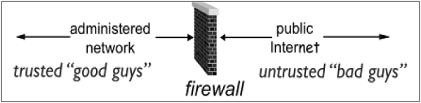
Deploying firewall at network boundary is like aggregating the security at a single point. It is analogous to locking an apartment at the entrance and not necessarily at each door.
Firewall is considered as an essential element to achieve network security for the following reasons −
- Internal network and hosts are unlikely to be properly secured.
- Internet is a dangerous place with criminals, users from competing companies, disgruntled ex-employees, spies from unfriendly countries, vandals, etc.
- To prevent an attacker from launching denial of service attacks on network resource.
- To prevent illegal modification/access to internal data by an outsider attacker.
Firewall is categorized into three basic types −
- Packet filter (Stateless & Stateful)
- Application-level gateway
- Circuit-level gateway
These three categories, however, are not mutually exclusive. Modern firewalls have a mix of abilities that may place them in more than one of the three categories.
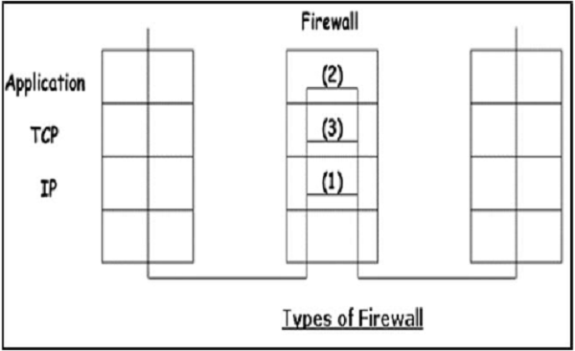
Stateless & Stateful Packet Filtering Firewall
In this type of firewall deployment, the internal network is connected to the external network/Internet via a router firewall. The firewall inspects and filters data packet-by-packet.
Packet-filtering firewalls allow or block the packets mostly based on criteria such as source and/or destination IP addresses, protocol, source and/or destination port numbers, and various other parameters within the IP header.
The decision can be based on factors other than IP header fields such as ICMP message type, TCP SYN and ACK bits, etc.
Packet filter rule has two parts −
- Selection criteria − It is a used as a condition and pattern matching for decision making.
- Action field − This part specifies action to be taken if an IP packet meets the selection criteria. The action could be either block (deny) or permit (allow) the packet across the firewall.
Packet filtering is generally accomplished by configuring Access Control Lists (ACL) on routers or switches. ACL is a table of packet filter rules.
As traffic enters or exits an interface, firewall applies ACLs from top to bottom to each incoming packet, finds matching criteria and either permits or denies the individual packets.
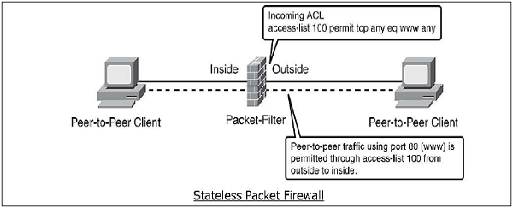
Stateless firewall is a kind of a rigid tool. It looks at packet and allows it if its meets the criteria even if it is not part of any established ongoing communication.
Hence, such firewalls are replaced by stateful firewalls in modern networks. This type of firewalls offer a more in-depth inspection method over the only ACL based packet inspection methods of stateless firewalls.
Stateful firewall monitors the connection setup and teardown process to keep a check on connections at the TCP/IP level. This allows them to keep track of connections state and determine which hosts have open, authorized connections at any given point in time.
They reference the rule base only when a new connection is requested. Packets belonging to existing connections are compared to the firewall's state table of open connections, and decision to allow or block is taken. This process saves time and provides added security as well. No packet is allowed to trespass the firewall unless it belongs to already established connection. It can timeout inactive connections at firewall after which it no longer admit packets for that connection.
Application Gateways
An application-level gateway acts as a relay node for the application-level traffic. They intercept incoming and outgoing packets, run proxies that copy and forward information across the gateway, and function as a proxy server, preventing any direct connection between a trusted server or client and an untrusted host.
The proxies are application specific. They can filter packets at the application layer of the OSI model.
Application-specific Proxies
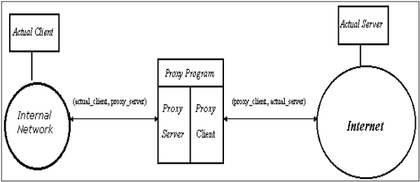
An application-specific proxy accepts packets generated by only specified application for which they are designed to copy, forward, and filter. For example, only a Telnet proxy can copy, forward, and filter Telnet traffic.
If a network relies only on an application-level gateway, incoming and outgoing packets cannot access services that have no proxies configured. For example, if a gateway runs FTP and Telnet proxies, only packets generated by these services can pass through the firewall. All other services are blocked.
Application-level Filtering
An application-level proxy gateway, examines and filters individual packets, rather than simply copying them and blindly forwarding them across the gateway. Application-specific proxies check each packet that passes through the gateway, verifying the contents of the packet up through the application layer. These proxies can filter particular kinds of commands or information in the application protocols.
Application gateways can restrict specific actions from being performed. For example, the gateway could be configured to prevent users from performing the ‘FTP put’ command. This can prevent modification of the information stored on the server by an attacker.
Transparent
Although application-level gateways can be transparent, many implementations require user authentication before users can access an untrusted network, a process that reduces true transparency. Authentication may be different if the user is from the internal network or from the Internet. For an internal network, a simple list of IP addresses can be allowed to connect to external applications. But from the Internet side a strong authentication should be implemented.
An application gateway actually relays TCP segments between the two TCP connections in the two directions (Client ↔ Proxy ↔ Server).
For outbound packets, the gateway may replace the source IP address by its own IP address. The process is referred to as Network Address Translation (NAT). It ensures that internal IP addresses are not exposed to the Internet.
Circuit-Level Gateway
The circuit-level gateway is an intermediate solution between the packet filter and the application gateway. It runs at the transport layer and hence can act as proxy for any application.
Similar to an application gateway, the circuit-level gateway also does not permit an end-to-end TCP connection across the gateway. It sets up two TCP connections and relays the TCP segments from one network to the other. But, it does not examine the application data like application gateway. Hence, sometime it is called as ‘Pipe Proxy’.
SOCKS
SOCKS (RFC 1928) refers to a circuit-level gateway. It is a networking proxy mechanism that enables hosts on one side of a SOCKS server to gain full access to hosts on the other side without requiring direct IP reachability. The client connects to the SOCKS server at the firewall. Then the client enters a negotiation for the authentication method to be used, and authenticates with the chosen method.
The client sends a connection relay request to the SOCKS server, containing the desired destination IP address and transport port. The server accepts the request after checking that the client meets the basic filtering criteria. Then, on behalf of the client, the gateway opens a connection to the requested untrusted host and then closely monitors the TCP handshaking that follows.
The SOCKS server informs the client, and in case of success, starts relaying the data between the two connections. Circuit level gateways are used when the organization trusts the internal users, and does not want to inspect the contents or application data sent on the Internet.
Cryptosystems
A cryptosystem is an implementation of cryptographic techniques and their accompanying infrastructure to provide information security services. A cryptosystem is also referred to as a cipher system.
Let us discuss a simple model of a cryptosystem that provides confidentiality to the information being transmitted. This basic model is depicted in the illustration below −
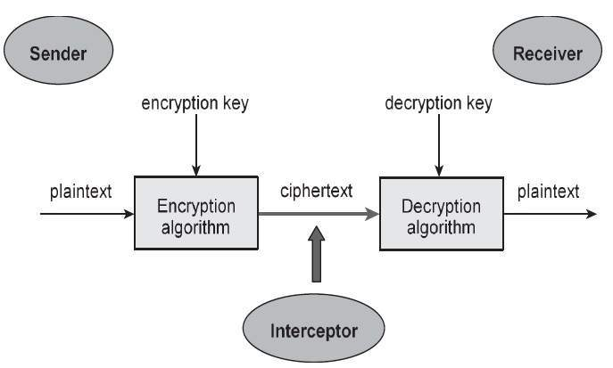
The illustration shows a sender who wants to transfer some sensitive data to a receiver in such a way that any party intercepting or eavesdropping on the communication channel cannot extract the data.
The objective of this simple cryptosystem is that at the end of the process, only the sender and the receiver will know the plaintext.
Components of a Cryptosystem
The various components of a basic cryptosystem are as follows −
- Plaintext. It is the data to be protected during transmission.
- Encryption Algorithm. It is a mathematical process that produces a ciphertext for any given plaintext and encryption key. It is a cryptographic algorithm that takes plaintext and an encryption key as input and produces a ciphertext.
- Ciphertext. It is the scrambled version of the plaintext produced by the encryption algorithm using a specific the encryption key. The ciphertext is not guarded. It flows on public channel. It can be intercepted or compromised by anyone who has access to the communication channel.
- Decryption Algorithm, It is a mathematical process, that produces a unique plaintext for any given ciphertext and decryption key. It is a cryptographic algorithm that takes a ciphertext and a decryption key as input, and outputs a plaintext. The decryption algorithm essentially reverses the encryption algorithm and is thus closely related to it.
- Encryption Key. It is a value that is known to the sender. The sender inputs the encryption key into the encryption algorithm along with the plaintext in order to compute the ciphertext.
- Decryption Key. It is a value that is known to the receiver. The decryption key is related to the encryption key, but is not always identical to it. The receiver inputs the decryption key into the decryption algorithm along with the ciphertext in order to compute the plaintext.
For a given cryptosystem, a collection of all possible decryption keys is called a key space.
An interceptor (an attacker) is an unauthorized entity who attempts to determine the plaintext. He can see the ciphertext and may know the decryption algorithm. He, however, must never know the decryption key.
Types of Cryptosystems
Fundamentally, there are two types of cryptosystems based on the manner in which encryption-decryption is carried out in the system −
- Symmetric Key Encryption
- Asymmetric Key Encryption
The main difference between these cryptosystems is the relationship between the encryption and the decryption key. Logically, in any cryptosystem, both the keys are closely associated. It is practically impossible to decrypt the ciphertext with the key that is unrelated to the encryption key.
Symmetric Key Encryption
The encryption process where same keys are used for encrypting and decrypting the information is known as Symmetric Key Encryption.
The study of symmetric cryptosystems is referred to as symmetric cryptography. Symmetric cryptosystems are also sometimes referred to as secret key cryptosystems.
A few well-known examples of symmetric key encryption methods are − Digital Encryption Standard (DES), Triple-DES (3DES), IDEA, and BLOWFISH.
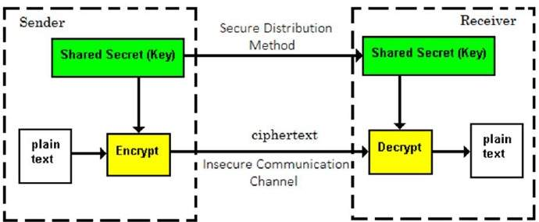
Prior to 1970, all cryptosystems employed symmetric key encryption. Even today, its relevance is very high and it is being used extensively in many cryptosystems. It is very unlikely that this encryption will fade away, as it has certain advantages over asymmetric key encryption.
The salient features of cryptosystem based on symmetric key encryption are −
- Persons using symmetric key encryption must share a common key prior to exchange of information.
- Keys are recommended to be changed regularly to prevent any attack on the system.
- A robust mechanism needs to exist to exchange the key between the communicating parties. As keys are required to be changed regularly, this mechanism becomes expensive and cumbersome.
- In a group of n people, to enable two-party communication between any two persons, the number of keys required for group is n × (n – 1)/2.
- Length of Key (number of bits) in this encryption is smaller and hence, process of encryption-decryption is faster than asymmetric key encryption.
- Processing power of computer system required to run symmetric algorithm is less.

Asymmetric Key Encryption
The encryption process where different keys are used for encrypting and decrypting the information is known as Asymmetric Key Encryption. Though the keys are different, they are mathematically related and hence, retrieving the plaintext by decrypting ciphertext is feasible. The process is depicted in the following illustration −
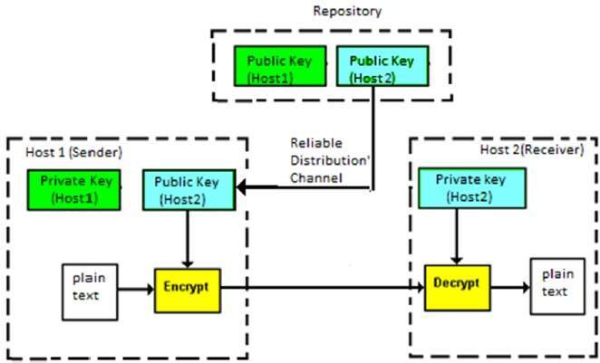
Asymmetric Key Encryption was invented in the 20th century to come over the necessity of pre-shared secret key between communicating persons. The salient features of this encryption scheme are as follows −
- Every user in this system needs to have a pair of dissimilar keys, private key and public key. These keys are mathematically related − when one key is used for encryption, the other can decrypt the ciphertext back to the original plaintext.
- It requires to put the public key in public repository and the private key as a well-guarded secret. Hence, this scheme of encryption is also called Public Key Encryption.
- Though public and private keys of the user are related, it is computationally not feasible to find one from another. This is a strength of this scheme.
- When Host1 needs to send data to Host2, he obtains the public key of Host2 from repository, encrypts the data, and transmits.
- Host2 uses his private key to extract the plaintext.
- Length of Keys (number of bits) in this encryption is large and hence, the process of encryption-decryption is slower than symmetric key encryption.
- Processing power of computer system required to run asymmetric algorithm is higher.
Symmetric cryptosystems are a natural concept. In contrast, public-key cryptosystems are quite difficult to comprehend.

Digital signatures are the public-key primitives of message authentication. In the physical world, it is common to use handwritten signatures on handwritten or typed messages. They are used to bind signatory to the message.
Similarly, a digital signature is a technique that binds a person/entity to the digital data. This binding can be independently verified by receiver as well as any third party.
Digital signature is a cryptographic value that is calculated from the data and a secret key known only by the signer.
In real world, the receiver of message needs assurance that the message belongs to the sender and he should not be able to repudiate the origination of that message. This requirement is very crucial in business applications, since likelihood of a dispute over exchanged data is very high.
Model of Digital Signature
As mentioned earlier, the digital signature scheme is based on public key cryptography. The model of digital signature scheme is depicted in the following illustration −
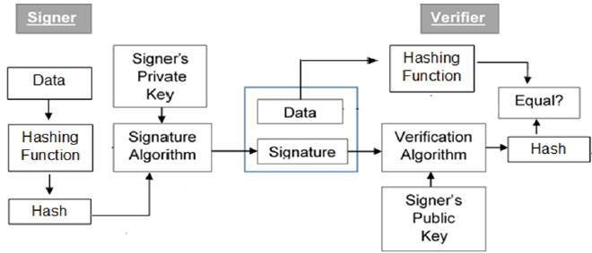
The following points explain the entire process in detail −
- Each person adopting this scheme has a public-private key pair.
- Generally, the key pairs used for encryption/decryption and signing/verifying are different. The private key used for signing is referred to as the signature key and the public key as the verification key.
- Signer feeds data to the hash function and generates hash of data.
- Hash value and signature key are then fed to the signature algorithm which produces the digital signature on given hash. Signature is appended to the data and then both are sent to the verifier.
- Verifier feeds the digital signature and the verification key into the verification algorithm. The verification algorithm gives some value as output.
- Verifier also runs same hash function on received data to generate hash value.
- For verification, this hash value and output of verification algorithm are compared. Based on the comparison result, verifier decides whether the digital signature is valid.
- Since digital signature is created by ‘private’ key of signer and no one else can have this key; the signer cannot repudiate signing the data in future.
It should be noticed that instead of signing data directly by signing algorithm, usually a hash of data is created. Since the hash of data is a unique representation of data, it is sufficient to sign the hash in place of data. The most important reason of using hash instead of data directly for signing is efficiency of the scheme.
Let us assume RSA is used as the signing algorithm. As discussed in public key encryption chapter, the encryption/signing process using RSA involves modular exponentiation.
Signing large data through modular exponentiation is computationally expensive and time consuming. The hash of the data is a relatively small digest of the data, hence signing a hash is more efficient than signing the entire data.
Importance of Digital Signature
Out of all cryptographic primitives, the digital signature using public key cryptography is considered as very important and useful tool to achieve information security.
Apart from ability to provide non-repudiation of message, the digital signature also provides message authentication and data integrity. Let us briefly see how this is achieved by the digital signature −
- Message authentication − When the verifier validates the digital signature using public key of a sender, he is assured that signature has been created only by sender who possess the corresponding secret private key and no one else.
- Data Integrity − In case an attacker has access to the data and modifies it, the digital signature verification at receiver end fails. The hash of modified data and the output provided by the verification algorithm will not match. Hence, receiver can safely deny the message assuming that data integrity has been breached.
- Non-repudiation − Since it is assumed that only the signer has the knowledge of the signature key, he can only create unique signature on a given data. Thus the receiver can present data and the digital signature to a third party as evidence if any dispute arises in the future.
By adding public-key encryption to digital signature scheme, we can create a cryptosystem that can provide the four essential elements of security namely − Privacy, Authentication, Integrity, and Non-repudiation.

